Use the Hoopla App
for mobile devices

Hoopla – eAudiobooks, Movies, Music, & TV

Have you ever wanted to watch movies & TV, listen to music or eAudiobooks on your Computer, Tablet, or Smartphone? Use Hoopla, MPL’s multimedia streaming service. There is a Hoopla app available for smartphones and tablets. (Note: you can check out 10 items a month.)
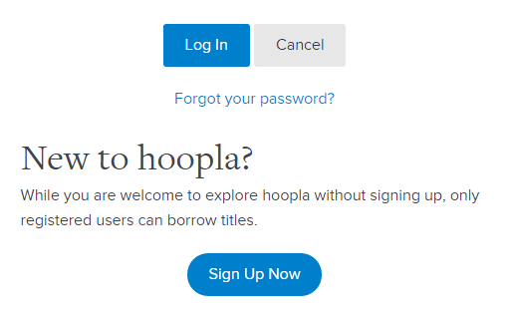

Set up your Hoopla Library Account:

- Go to www.Mentorpl.org.

- Click on the Hoopla! logo.

- Click Log In.

- Returning users please Log In with your email address and password.
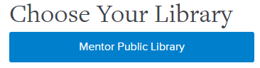
- New users click Sign Up Now.
  - Choose Mentor Public Library from the list of libraries provided.
  - Fill in your personal information (email address & password).
  - Input your library card number.
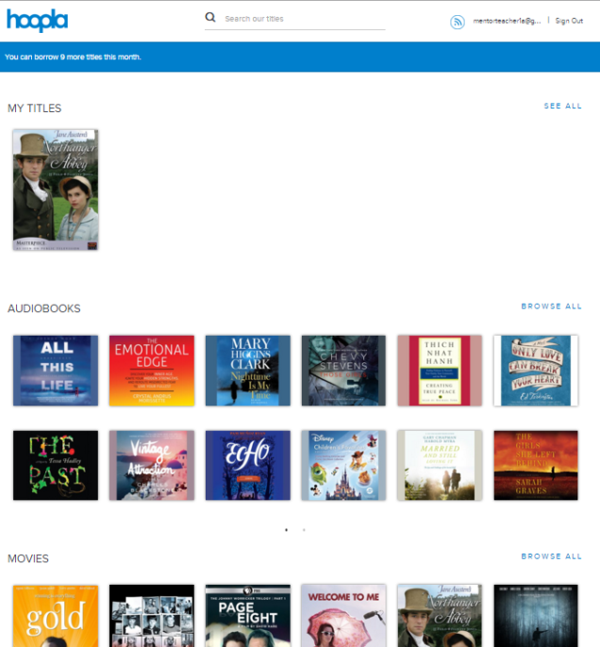
  - Click Continue.

Check out items in Hoopla

- Sign in to Hoopla.

- Scroll down the page to browse available items.
  - Any items you have already checked out will be displayed in the My Titles area.
  - 23199003964841You can download Audiobooks, Movies, Music, Comics, eBooks, & TV shows.
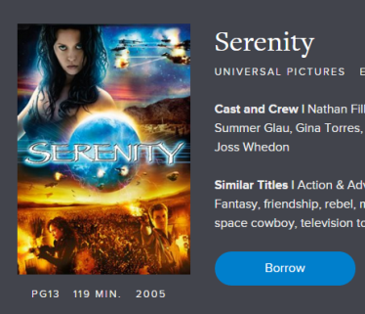
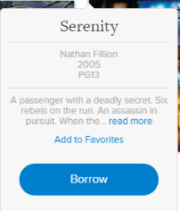
  - Click Browse All to see more of that item type.

- To quickly borrow the item, hover the mouse and click Borrow.

- To read a description click on the item. Click Borrow.

- The item will become available under the My Titles area.

- Select the desired item.

- Click Play.

- To return an item, click on the Or Return Now link listed after the return date under the item description.
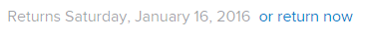

Hoopla check out limits:
- 12 items per month

Lending Periods:
- TV & Movies – 3 day
- Music – 7 days
- Audiobooks, Comics, & eBooks – 3 weeks

Items will automatically return themselves at the end of the lending period.

This service streams the item to your computer.

If you use the Hoopla app on a mobile device, items can be downloaded to the device. Once the item has been downloaded, you do not need to have an Internet connection to view the item.

Each TV episode counts as 1 item checkout.
To create a “Waiting list”:
- Open the item.
- Click Add as Favorite.

Open your My Titles and open your Favorite list to see items. In this manner, your Favorite list can become a Waiting List.

