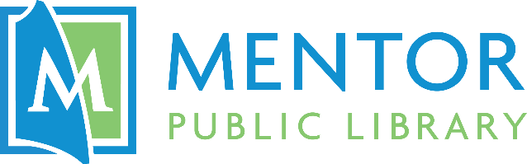

Makerspace @ The HUB User Agreement
I, _________________ (name), have read the Mentor Public Library’s Makerspace @ The HUB Procedures and agree to follow all rules, policies, procedures, and restrictions relating to use of The HUB’s Makerspace. I understand that these rules, policies, procedures, and restrictions may change at any time without notice and that I will make myself aware of all changes or modifications of said rules, policies, procedures, and restrictions.
I agree that by signing this agreement and/or utilizing The HUB’s Makerspace, I shall defend, indemnify, and hold harmless both Mentor Public Library and Mentor Public Schools, their trustees, officers, officials, employees, and volunteers from and against any and all claims, suits (including attorney’s fees), actions, or liabilities for injury or death of any person, or for loss or damage to property, which arises out of my use of The HUB’s Makerspace.
I certify that I am not violating the intellectual property rights of any other person or entity in my use of The HUB’s Makerspace equipment. I agree to pay for any and all fees or fines involved with my use of The HUB’s Makerspace.

The HUB Makerspace User Agreement

Name:___________________________________________ Phone No.:___________________
Address:______________________________________________________________________
Library Card No.:______________________________________________________________

Signature:_______________________________________ Date:_________________________
(18+ only. For minors, continue below.)

Parent or Legal Guardian Information
Parent/Guardian Full Name: ____________________________________________________
Parent/Guardian Library Card No.:_______________________________________________

Parent/Guardian Signature:____________________________ Date:____________________

